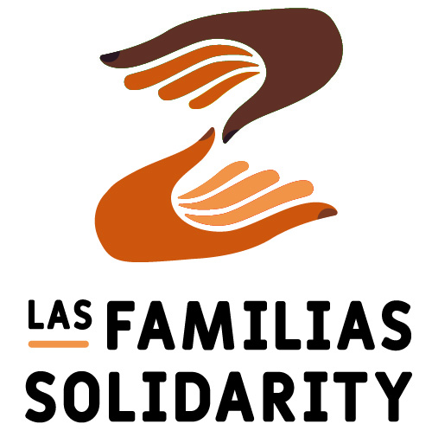 **Ways that you can volunteer**

**to make a difference to so many:**

* **Donors** – Contribute needed shelter supplies, or contribute to our fund to purchase items in bulk.
* **Prayers** – The power of prayer is greatly needed for the frontline staff, volunteers and asylum seeking refugees
* **Gatherers** – Do you have a social network? Gather family/friends/neighbors to contribute requested items.
* **Drivers –** Come join us as we deliver critical supplies to the Asylum Seeker Shelters in El Paso. It’s a long day (6 a.m. – 7 p.m.), but rich in inspiring experiences.
* **Bakers** – Use your talent to bake cookies for weary asylum seekers & volunteers at the shelters.
* **Knitters/ Crocheters** – Calling creative people! Create warm children’s or adult winter hats and mittens for the asylum seekers in cold weather.
* **Advocates** – Write letters, emails and call government leaders in support of Immigrant rights. Our monthly report contains advocacy links to protect immigrants’ rights.
* **Shoppers** – Are you a good researcher? Help us find good quality, wholesale sources for the urgently needed shelter supplies.

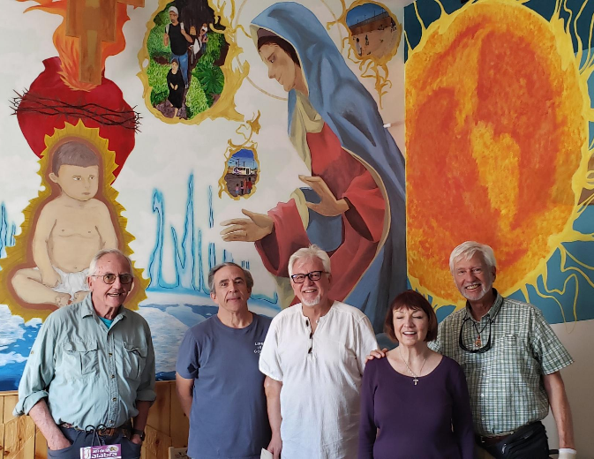

* **Organizer** - Assist Las Familias Solidarity in unpackaging, counting sorting and labeling items.
* **Volunteer** – Are you ready for a life changing experience? Volunteer for 2 weeks or longer at AnnunciationHouse.org. Food and lodging in El Paso is included.

Interested? Contact Liz Hanna at [Liz_Hanna@hotmail.com](mailto:Liz_Hanna@hotmail.com) or 262-424-3382