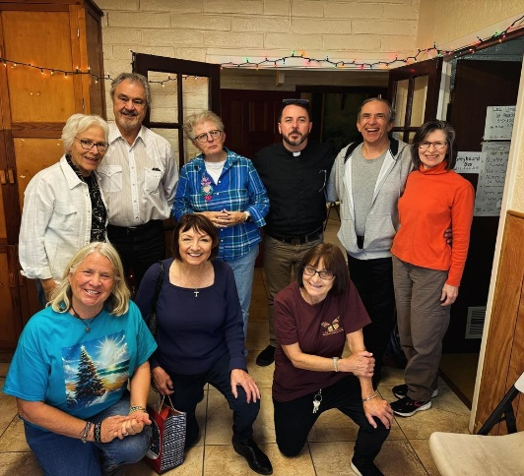**Our Purpose**

* To **expedite items** needed for the asylum seekers quickly to Annunciation House sites in El Paso
* To **support** the staff and volunteers at 7 different asylum seeker shelters through staff relationships and donations of only requested supplies.
* To **illuminate** the human stories of asylum seekers at the El Paso/Juarez border.
* To **educate** those concerned about immigration issues at our southern border.
* To **activate**those who care, but did not know how to support asylum seekers.
* To **advocate**, highlighting opportunities for caring people to affect US policy.

Our work begins after the asylum seeking families have been processed and allowed access into our country by US Customs and Border Protection. They are transported by ICE to a network of Annunciation House shelters. There, the asylum seekers will receive a hot shower, hot meal, change of clothing, basic medical needs and help to connect with their US sponsor. After a few days, the asylum seeking families will be driven to the air/bus/train terminal, with their ticket which was purchased by their sponsor or a non-profit.

Las Familias Solidarity has been serving the Annunciation House shelters in El Paso, Texas for 4 years. Our parish, St. Michael & All Angels Episcopal Church, is the umbrella for our 501c3 status. First Congregational UCC and Congregation B’nai Israel also collect shelter needs for us to deliver. We also have 4 organizations that support us.

We have cultivated strong, working relationships and effective communications with the managers and volunteers at various Annunciation House network of shelters, which run totally on donations and volunteers. We meet with the various shelter staffs each month to support them and find out what is really happening at the El Paso/Juarez border.

Each month, we deliver ONLY **the most critically needed and requested items to** 3 shelters with the greatest needs in El Paso. We buy in bulk whenever possible, and scout the best prices on each item to lower item costs. Our different teams of 27 volunteers total prep all donations, remove any store packaging and tags, sort by gender and size, bag and label all items for easy processing by shelter volunteer staffs. Each month we bring needed supplies in 3-4 fully loaded SUV’s to El Paso. These items cannot be shipped directly because of the confidentiality of the shelter addresses. Las Familias Solidarity is totally funded by donations, grants and in-kind donations. **The value of the 2023 donations totaled $81,600**! Our sponsors include individuals, congregations and organizations. **100% of all donations go directly to the shelters**. Our volunteers donate all transportation, repackaging, printing and mailing costs.

We believe that the most important work of Las Familias Solidarity is our **Monthly Border Trip Report** that we send to over 200 donors. Each month, we highlight the very real human struggles of immigrants at the El Paso/Juarez border, and provide the latest developments of US immigration policies, and enforcement by Customs and Border Protection. We also build awareness through advocacy information and “action” opportunities to reform US Immigration Law and policies.

Thank you for your interest, prayers and support!

Liz, Mike, Sharon, Denise, Linda

Liz & Mike Hanna, Sharon Palma, Denise Ulibarri Clauss, , Linda McCreary

For more information, please contact : Liz Hanna, l[iz_hanna@hotmail.com](mailto:iz_hanna@hotmail.com), 262-424-3382